TNOTA Approved Provider Program
Instructions & Application
Directions for Submitting Proposals
- Review the below application and criteria carefully
- Send any questions or concerns to continuinged@tnota.org
- Ensure that all sections of the Approved Provider Program application have been completed
- Complete a separate application for each course you are submitting
Application submissions are due no later than 30 days prior to the scheduled course date.

Directions for using True Approve
TNOTA partners with a platform called True Approve to digitally manage our Approved Provider Program submissions. Below are some instructions to assist you through the submission process.
You will be required to register for a True Approve account to communicate with the continuing education committee throughout this process.
https://trueapprove.dabrinteractive.com/Register/TNOTA
When creating an account, in the drop-down menu "Provider Type", you MUST select CE Provider.
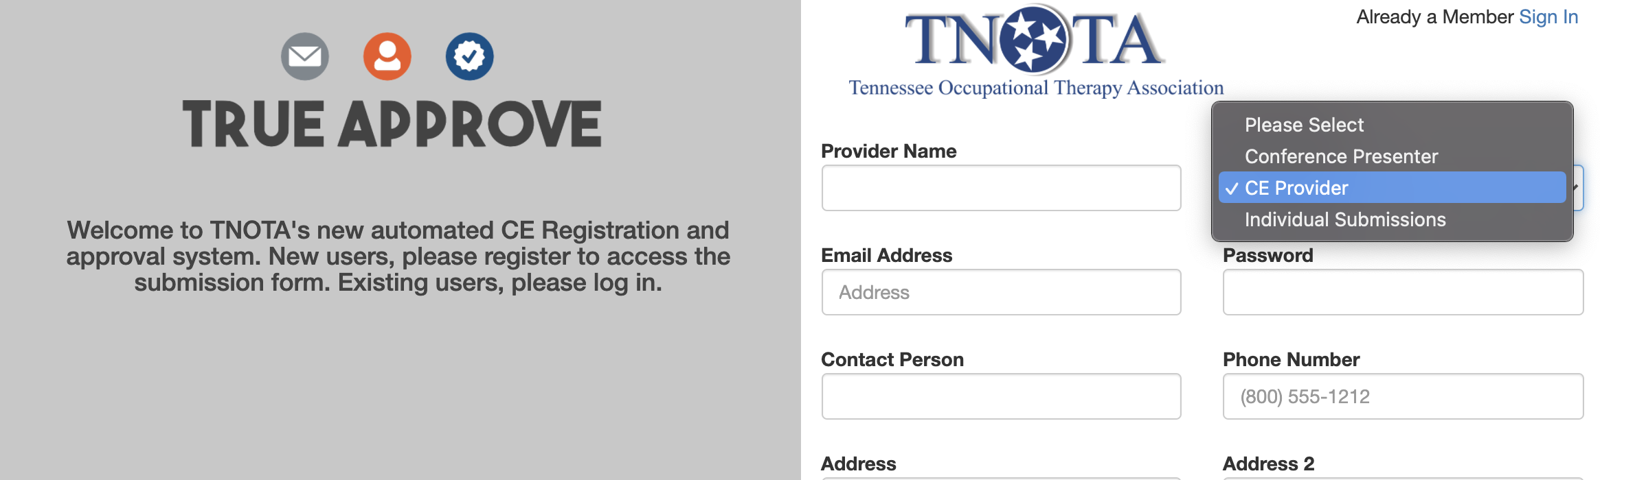

After you have created an account follow these steps:
- Login to True Approve
- Click “My Courses” on the left side of screen
- Select “Add New”
- Fill out all form fields completely. (Incomplete forms will not be processed.)
- You can add multiple presenters on your application form, but the person who fills out the registration will be the primary contact.
- You must complete the “TNOTA Approved Provider Program application” document and submit it with your True Approve Application using the “upload attachment” link. This application can be downloaded from the TNOTA website and is attached at the end of this document.

You will be notified via email if TNOTA requires additional information and when your course is approved or denied. Notifications will be sent out within 30 days of receipt of your completed application.

TNOTA Approved Provider Program
Application Form

- Primary Presenter Name & Credentials (upload resume to True Approve):

- Additional Presenter(s) Name and Credentials (upload resume(s) to True Approve):

- Course Title:

- Course Date (or time frame, if multiple dates):

- Course Type (select):
In-person Course or Workshop
Online Course
Self-study

- Level of Material:
Beginner/Introductory
Intermediate
Advanced

- Beginner/Introductory level is geared toward practitioners with little or no knowledge of the subject matter. Focus is on providing general introductory information.
- Intermediate level is geared toward practitioners with a general working knowledge of current practice trends and literature related to the subject matter. Focus is on increasing knowledge and competent application of the subject matter.
- Advanced level is geared toward practitioners with a comprehensive understanding of the subject matter based on current theories and standards of practice as well as current literature and research. Focus is on recent advances and trends and/or research applications. It is expected that a high-level of participation by attendees is encouraged during this type of course.

- Length of course (contact hours are awarded in 15 minute increments):
- Course Objectives-- Provide a minimum of 3 clear, concise course objectives for your proposed presentation with indication of the target audience:
    - Objective 1
    - Objective 2
    - Objective 3

- Course Description (250 words or less):

- Abstract-- Provide an edited abstract (50 words or less) that may be printed on our website for informational purposes:

- Brief description of how participants will demonstrate achievement of objectives (e.g. post test, case study, demonstration of techniques, etc.):

- References (3 or more references from peer reviewed journals within the last 5 years):

Questions regarding this application and approval process can be submitted to continuinged@tnota.org
Technical questions about TrueApprove’s platform can be directed to info@dabrinteractive.com

TNOTA Approved Provider Program
Application Materials Checklist

Please submit COMPLETED APPLICATION MATERIALS no later than 30 days prior to your course date.
Submit all materials using True Approve
Application Packet Checklist:
Approved Provider Program Application Form
Resume/CV for each course presenter
Course agenda with times, including meal and break times (if applicable)
Presenter disclosure form (found at the end of this document)
Handouts or slides in PDF form

TNOTA Approved Provider Program
Presenter Disclosure Form
This presenter disclosure form is made in reference to any content that is being submitted for approval via the Tennessee Occupational Therapy Association, Inc.’s (“TNOTA”) Approved Provider Program. For the purposes of this agreement, “Content” means any information, data, works or authorship including videos, images, lectures, course materials, and syllabi.
Copyright & Fair Use of Content
I attest that to the best of my knowledge, I have all necessary right and authority to grant the rights herein granted with respect to the Content I upload, share or otherwise provide in connection with my engagement in the Approved Provider Program. I attest that to the best of my knowledge none of the Content contained within my submission is copyrighted, and that all content is used within the parameters of the Fair Use doctrine.
I further represent that I have used and will use best efforts; (i) not to incorporate or use any libelous, slanderous or infringing Content; (ii) not to incorporate or use any Content containing obvious bias or discriminatory language; and (ii) to consider learners with disabilities in the preparation and presentation of Content for such course(s), such as verbally describing visual elements for the visually impaired.

Changing Content Following Submission
I attest that to the best of my knowledge, Content I submit for approval with TNOTA’s Approved Provider Program will remain unchanged between the time of approval and the course date(s).
I acknowledge that if I make changes to the content following initial submission, I will submit notice of changes to TNOTA at least 30 days prior to course date(s). I understand that my application may not be changed once fully completed and approved.

Conflict of Interest Disclosure
Please describe below any relationships, either personal, professional, or financial, as well as transactions, positions you hold (volunteer or otherwise), or circumstances that you believe could contribute to a conflict of interest relevant to TNOTA’s Approved Provider Program, its application and submission process, and/or course content:

I have no conflict of interest to report.

I have the following conflict of interest to report (please specify):

______________________________________________________________________________

I attest that I will not represent a vendor or sell products as a part of this presentation.

I herby release, discharge, promise not to sue, and hold harmless TNOTA and its affiliates, successors and assigns from and against any and all claims, demands and/or causes of action arising out of or in connection with the exercise of any rights herein granted, including, without limitation, any claim for infringement, right of publicity, libel, slander, defamation, moral rights, invasion of privacy or violation of any other rights relating to any Content I upload, share or otherwise provide in connection with use of the Platform.
I certify and represent that I have read this Release and fully understand its meaning and effect.

Applicant Printed Name: ________________________________________
Applicant Signature: ____________________________________________
Date: ________________________________________________________
Course Name: _________________________________________________

