Coverage for Telehealth Services In Tennessee
**This information was gathered through an effort of TNOTA’s advocacy team. It is current, to the best of our knowledge, as of March 27, 2020. ***
Traditional Medicare (part A and B):

E-Visits are the only covered services. E-visits are defined as, “In all types of locations including the patient’s home, and in all areas (not just rural), established Medicare patients may have non-face-to-face patient-initiated communications with their doctors without going to the doctor’s office by using online patient portals. These services can only be reported when the billing practice has an established relationship with the patient. For these E-Visits, the patient must generate the initial inquiry and communications can occur over a 7-day period. “
Medicare Codes to utilize for E-visits ONLY:
- G2061: Qualified non-physician healthcare professional online assessment and management, for an established patient, for up to seven days, cumulative time during the 7 days; 5–10 minutes
- G2062: Qualified non-physician healthcare professional online assessment and management service, for an established patient, for up to seven days, cumulative time during the 7 days; 11–20 minutes
- G2063: Qualified non-physician qualified healthcare professional assessment and management service, for an established patient, for up to seven days, cumulative time during the 7 days; 21 or more minutes.

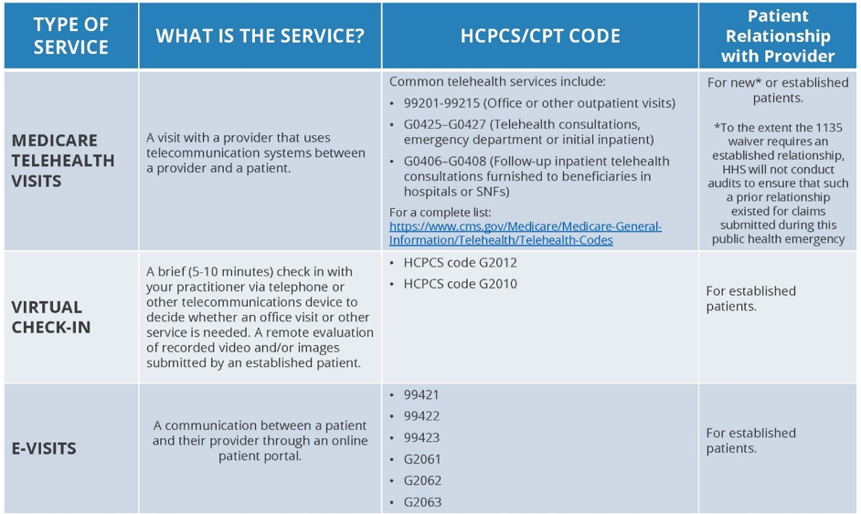
Information obtained from: https://www.cms.gov/newsroom/fact-sheets/medicare-telemedicine-health-care-provider-fact-sheet

United Health Care
The following codes are covered for telehealth, through June 18, 2020.
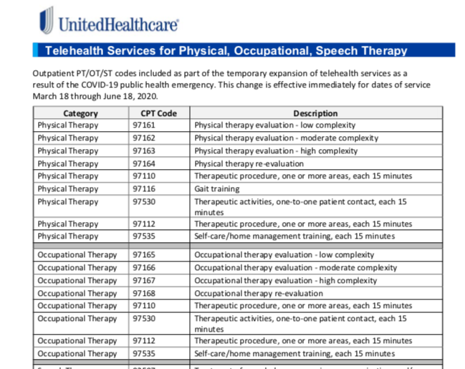

Aetna:
For the next 90 days (written on March 17, 2020), Aetna will cover minor acute evaluation and management services rendered via telephone. A visual connection is not required. For general medicine and behavioral health visits – a synchronous audiovisual connection is still required. Aetna’s telemedicine policy is available to providers on the NaviNet and Availity portals.
Codes covered by these changes appropriate to OT/PT/ST:
G2061, G2062, G2063 - Qualified nonphysician healthcare professional online assessment, for an established patient, for up to seven days, cumulative time during the 7 days; 5-10 minutes; 11 – 20 minutes; or 21 or more minutes
98970, 98971, 98972 - Qualified nonphysician health care professional online digital evaluation and management service, for an established patient, for up to 7 days, cumulative time during the 7 days; 5-10; 11-20; or 21 or more minutes.
Information obtained from: https://www.aetna.com/health-care-professionals/provider-education-manuals/covid-faq.html#acc_link_content_section_responsivegrid_copy__responsivegrid_accordion_10

Contact Aetna
Cigna:
Cigna does not specifically name providers that can perform telehealth services. On their FAQ page it states, “All providers can deliver virtual care to Cigna customers when the services are billed consistently with the guidance on pages 3-5. We are implementing this enhanced measure through May 31, 2020 to protect our customers by mitigating exposure risks and alleviating transportation barriers.” It would appear that OT/PT/ST would fall under this. No specific CPT codes are given at this time per conversation with CIGNA customer service representative, but will be available in the coming days.
Information obtained from: https://static.cigna.com/spa/chcp/assets/Cigna-COVID-19-Billing-Guidiance-for-Providers-3-18.pdf
Contact cigna
Blue Cross Blue Shield Tennessee
BCBS TN are covering PCP/Physician or behavioral health visits only: “From now until April 30, you can use CPT codes 99441–99443 for telephonic provider-to-member consultation. This applies to all lines of business’s PCP or specialist benefits. You can also bill for virtual and telephonic consults with your patients by using E&M codes 99201–99215 from now through April 30. For behavioral health consultations, use codes 90791, 90792, 90832, 90834 and 90837.” OT/PT/ST not mentioned as covered providers on their website.
Information obtained from: https://bcbstupdates.com/provider-faq/
Contact BCBS
Medicaid: Tenncare, Bluecare, Amerigroup, UHCCP
As of 3/27, all Tenncare (Bluecare, Amerigroup, UHCCP) are covered through May 31.
Information obtained from: https://www.tn.gov/content/dam/tn/tenncare/documents/TennCareMCOCOVID19TelehealthDxTestingUpdate.pdf
https://www.tn.gov/content/dam/tn/finance/fa-benefits/documents/coronavirus_public_info.pdf

TRICARE
OT/PT/Speech Not currently covered.
Information obtained from: https://tricare.mil/CoveredServices/BenefitUpdates/Archives/03_24_2020_TRICARE_covers_certain_telemedicine_services

Contact Tricare

