TNOTA Annual Conference
Call for Papers
Policies Governing Accepted Proposals
Please agree to the “Policies Governing Accepted Proposals” and keep a copy for your reference.

Policies Governing Accepted Proposals
□ Once a proposal is accepted as a session, changes to the proposal may not be made.
□ TNOTA reserves the right to assign the day and time that accepted proposals will be scheduled.
□ All OT, OTA, and student speakers who proposals are accepted for presentation must register for at least one day of conference. Accepted speakers will be given a discounted rate to conference.
□ Notification will be sent by email by end of June 2021 regarding acceptance of proposals. Notifications not acknowledged by July 12, 2021 will result in a session being dropped from the final program.
□ Standard audiovisual equipment will be available for each presentation, with the exception of poster presentations.
□ Presenters are expected to provide a session handout for their presentations. These handouts will be posted on the TNOTA website for registered attendees to access.

□ I understand and accept the policies and deadlines for proposal submission.

TNOTA Annual Conference
September 10-12, 2021
Scarritt Bennett Center
Nashville, TN
Call for Papers
Directions for Submitting Proposals
- Review the Call for Papers directions carefully
- Send any questions or concerns to conferencecommittee@tnota.org
- Ensure that all sections of the Call for Papers have been completed
Call for papers submissions are due by May 24, 2021.
Our 2021 Annual conference theme is “Occupational Therapy: Meaningful Connections through Meaningful Occupations.”
For our 2021 annual conference, TNOTA is once again partnering with True Approve to digitally manage our conference submissions for the 2021 TNOTA Conference. Below are some instructions to assist you through this process.
You will be required to register for a True Approve account to communicate with the conference committee throughout this process.
https://trueapprove.dabrinteractive.com/Register/TNOTA
When creating an account, in the drop-down menu "Provider Type", you MUST select Conference Presenter.
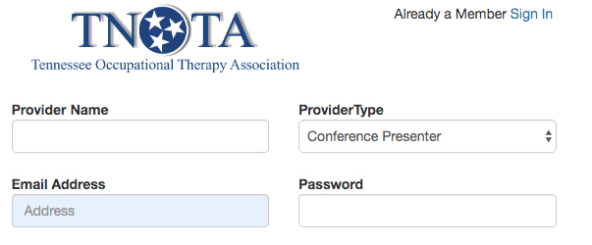

After you have created an account follow these steps:
- Login to True Approve
- Click “My Presentations” on the left side of screen
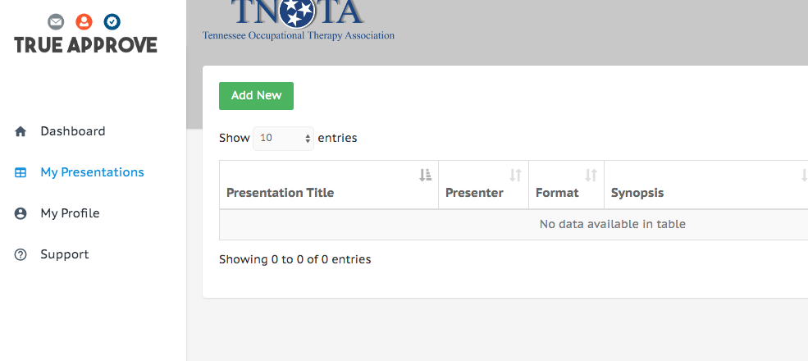
- Select “Add New”
- This form must be filled out completely. (Incomplete forms will not be processed.)
- You can add multiple presenters, but the person who fills out the registration will be the primary contact.
- You must complete the “TNOTA Conference 2021 Presentation Submission Supporting Documentation” document below and submit it with your True Approve Application using the “upload attachment” link. This document can be downloaded from the TNOTA website and is attached at the end of this document.

You will be notified via email if TNOTA requires additional information and when your presentation is approved or denied for TNOTA Conference 2021. Notifications will be sent out by end of June 2021.

TNOTA Annual Conference 2021
Supporting Documentation

TNOTA’s Annual Conference will be held Saturday, September 11 through Sunday, September 12, 2021 at Scarritt Bennett Center in Nashville, TN. Pre-conference will be held on Friday, September 10.
Our 2021 Annual conference theme is “Occupational Therapy: Meaningful Connections through Meaningful Occupations.”
Primary Presenter Name & Credentials:
  - Biographical information for each presenter in brief narrative format (100 words or less and ready to print). Please provide the following information:
a. Degree(s) and where earned
b. Professional experience
c. Any publications or research history
d. Awards/honors
e. Other information of interest

- Additional Presenter(s) Name and Credentials:

- Proposed Session Title
Be concise and descriptive

- Session Format
Please choose the session format for your presentation:
- Workshop: 1 hour and 45 minute session with reflective period for attendees with comprehensive understanding of subject matter
- Short Course: 50 minute session with reflective time for attendees
- Poster: Displayed on an 8’ wide x 4’ tall bulletin board.* Posters will be on display during a designated 2-hour time period. Presenters are required to be with their poster for the entire 2-hour bock of time.
*TNOTA will provide easels for display, but WILL NOT provide poster backing board

- Level of Material
Please select the level of material being presented:
- Introductory level is geared toward practitioners with little or no knowledge of the subject matter. Focus is on providing general introductory information.
- Intermediate level is geared toward practitioners with a general working knowledge of current practice trends and literature related to the subject matter. Focus is on increasing knowledge and competent application of the subject matter.
- Advanced level is geared toward practitioners with a comprehensive understanding of the subject matter based on current theories and standards of practice as well as current literature and research. Focus is on recent advances and trends and/or research applications. It is expected that a high-level of participation by attendees is encouraged during this session.
- Poster

Please select the level of material being presented:
☐ Introductory ☐ Intermediate □ Advanced

- Topic Area (check all that apply):
☐ Psychosocial ☐ Pediatric ☐ Adult ☐ Geriatric ☐ General
☐ Developmental ☐ Ortho ☐ Neuro ☐ Cognition ☐ Vision
☐ General Practice

VI. Objectives: Course objectives: Provide a minimum of 3 clear, concise course objectives for your proposed presentation with indication of the target audience.
1.
2.
3.

- Course Synopsis (250 characters or less):

- Abstract: Provide an edited abstract (50 words or less) that may be printed in the conference program without additional editing.

- Additional Questions

Please indicate:
- I am willing to have my live course or workshop recorded for future playback. (If yes, TNOTA will provide a speaker release form).
____ Yes
____ No

- This course is part of TNOTA’s student track.
____ Yes
____ No

Call for papers is open through May 24, 2021. We will work with presenters to schedule their sessions once all submissions are received in early July. Once your submission is accepted, a member of the conference committee will reach out to make arrangements and provide further details.

Presenters will receive a 50% discount on all courses held during the conference.

Questions regarding this process can be submitted to conferencecommittee@tnota.org. Technical questions about TrueApprove’s platform can be directed to info@dabrinteractive.com

TNOTA Annual Conference
September 10-12, 2021
Scarritt Bennett Center
Nashville, TN
Call for Papers
Proposal Materials Checklist

Please submit COMPLETED PROPOSAL MATERIALS no later than May 24, 2021
Submit materials using True Approve
Proposal Packet Checklist:
□ 1 copy of Policies Governing Accepted Proposals
□ 1 Copy of the completed Call for Papers Supporting Documentation Form

